**Task 3: Analyze Network** **Traffic**

• **OBJECTIVE**

Task: Monitor and analyze network traffic.

Details:

Use a tool like Wireshark to capture and analyze network packets.

Identify common network protocols and traffic patterns.

• **STEPS**

**1: Launch Wireshark:**

o Opened the Wireshark application, which displayed available network interfaces

such as Wi-Fi and local area connections.

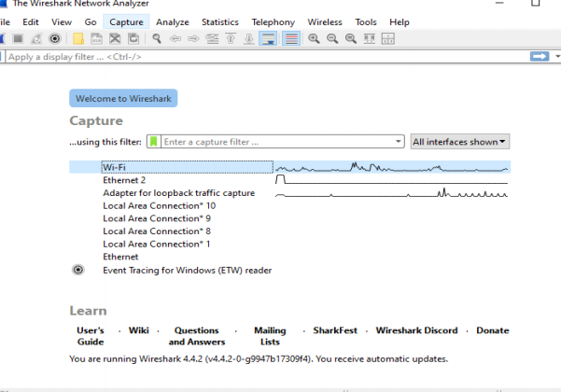

**2: Select Network Interface:**

• Choose the **Wi-Fi** interface to start monitoring the wireless network traffic.

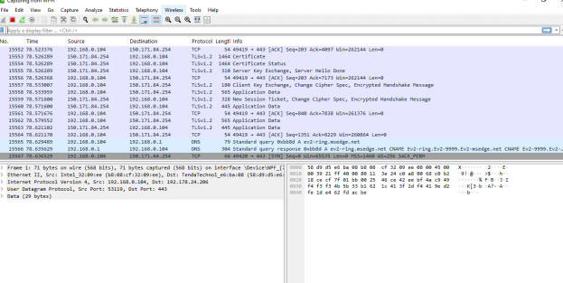

**3: Capture Packets:**

• Initiated the packet capture, allowing Wireshark to record all network traffic over the

selected interface. I collected a total of **141 packets** for analysis

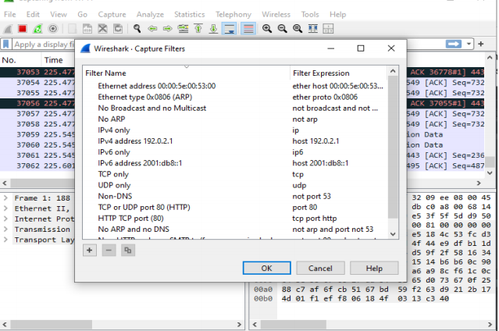

.**4: Apply Display Filters:**

• From the **Analyze** option in the top menu, I accessed the **Display Filter** section, which

showed various predefined filters.

• In the top search bar labeled "Apply a display filter," I typed **tcp** to filter and display all TCP related packets.

• Similarly, I applied the **udp** filter, which displayed only UDP packets.

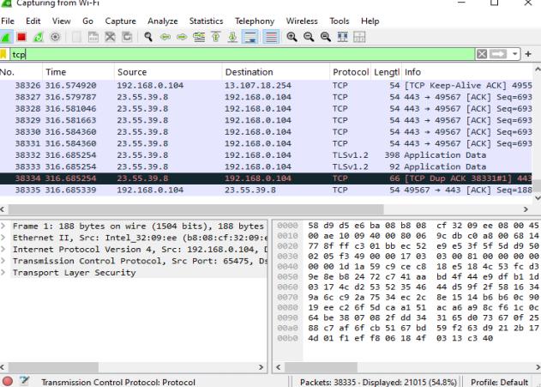

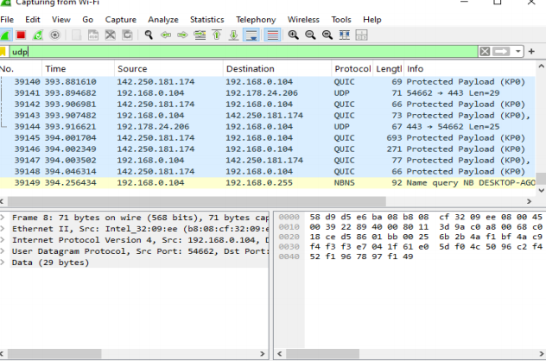

**5: View I/O Graphs:**

• Click on **Statistics** in the top menu and select **I/O Graphs** to view a graphical representation of network traffic. The graph displayed TCP traffic errors, allowing for further analysis.

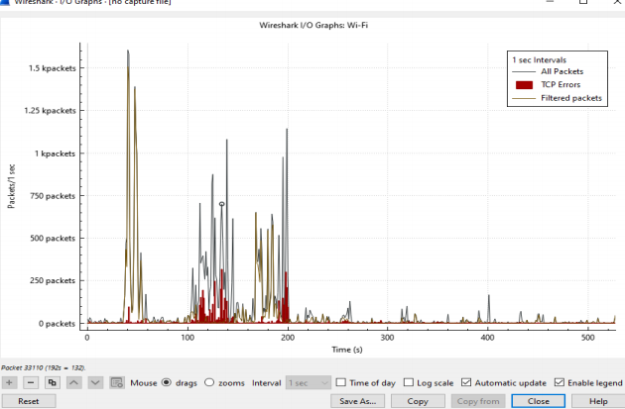

**6: Analysis of Packets:**

i. **Initial Handshake (TCP, TLS, ǪUIC)**:

* Packets 1-3 show the **TCP three-way handshake** between the local machine and an external server, indicating the start of a communication session.

ii. **Encrypted Traffic**:

* Many packets (such as 10, 12, 14) involve **encrypted TLS data**.

iii. **ǪUIC Protocol**:

* Packets like 50-90involveǪUIC, relatively new protocol running over UDP for

faster and more secure web communications (used by platforms like Google).

iv. **Connection Resets and Alerts**:

* Packets like 21 and 22 show **RST, and ACK flags**, indicating connection resets.

Reset flags can suggest issues with connections or intentional termination.

v. **DNS Ǫueries**:

* Packets 43 and 44 show **DNS queries** from your local machine to the router, specifically querying the domain google.com.